RECORD OF PROCEEDINGS
AIR FORCE BOARD FOR CORRECTION OF MILITARY RECORDS

IN THE MATTER OF: DOCKET NUMBER: BC-2006-02975
INDEX CODE: 107.00
XXXXXXXXXXXXXXXXXXXXXXXXX COUNSEL: NONE

HEARING DESIRED: NOT INDICATED

MANDATORY CASE COMPLETION DATE: 1 Apr 2008

________________________________________________________________

APPLICANT REQUESTS THAT:

He be awarded the Air Force Commendation Medal with Valor (AFCM w/V).

________________________________________________________________

APPLICANT CONTENDS THAT:

The AFCM awarded to him was given to him in combat for the job he did in combat.

In support of the appeal, applicant has submitted a picture of himself, alleged to have been taken while in the Republic of Vietnam (RVN), and a Vietnam map.

Applicant’s complete submission, with attachments, is at Exhibit A.

________________________________________________________________

STATEMENT OF FACTS:

The AFCM is awarded for outstanding achievement or meritorious service, or acts of courage that do not meet the requirements for award of the Airman’s Medal or Bronze Star Medal. Award of the “V” device for a contingency deployment operation will be dependent on the AOR being declared a hostile environment by the JCS, or hostile acts identified by the unified commander or higher authority. Award of the “V” device is based solely on the acts or services of individuals who meet the basic criteria for award of the AFCM, and who are exposed to personal hazards due to direct hostile action during a contingency deployment operation; however, award of the “V” device is authorized only for events or situations which occurred on or after 11 January 1996.

Applicant was awarded the AFCM for meritorious service while assigned to the 632nd Supply Squadron, RVN, for the period 10 September 1967 to 11 July 1968.

________________________________________________________________

AIR FORCE EVALUATION:

AFPC/DPPPR recommends denial since a thorough search of applicant’s records cannot verify his entitlement to this award with the “V” device, as well as the fact that applicant received his AFCM for the period September 1967 to July 1968.

The AFPC/DPPPR evaluation is at Exhibit C.

________________________________________________________________

APPLICANT'S REVIEW OF AIR FORCE EVALUATION:

A complete copy of the evaluation was forwarded to the applicant on 17 November 2006, for review and comment, within 30 days. However, as of this date, no response has been received by this office.

________________________________________________________________

THE BOARD CONCLUDES THAT:

1. The applicant has exhausted all remedies provided by existing law or regulations.

2. The application was not timely filed; however, it is in the interest of justice to excuse the failure to timely file.

3. Insufficient relevant evidence has been presented to demonstrate the existence of error or injustice. We took notice of the applicant's complete submission in judging the merits of the case; however, we agree with the opinion and recommendation of the Air Force office of primary responsibility and adopt its rationale as the basis for our conclusion that the applicant has not been the victim of an error or injustice since he received his AFCM for the period September 1967 to July 1968, well before 11 January 1996, the date established as the beginning eligibility date for award of the “V” device. Therefore, in the absence of evidence to the contrary, we find no compelling basis to recommend granting the relief sought in this application.

________________________________________________________________

THE BOARD DETERMINES THAT:

The applicant be notified that the evidence presented did not demonstrate the existence of material error or injustice; that the application was denied without a personal appearance; and that the application will only be reconsidered upon the submission of newly discovered relevant evidence not considered with this application.

________________________________________________________________

The following members of the Board considered Docket Number BC-2006-02975 in Executive Session on 17 January 2007, under the provisions of AFI 36-2603:

Mr. Thomas S. Markiewicz, Chair
Ms. Karen A. Holloman, Member
Mr. Wallace E. Beard, Jr., Member

The following documentary evidence was considered:

Exhibit A. DD Form 149, undated, w/atchs.
Exhibit B. Applicant's Master Personnel Records.
Exhibit C. Letter, AFPC/DPPPR, dated 6 Nov 06.
Exhibit D. Letter, SAF/MRBR, dated 17 Nov 06.

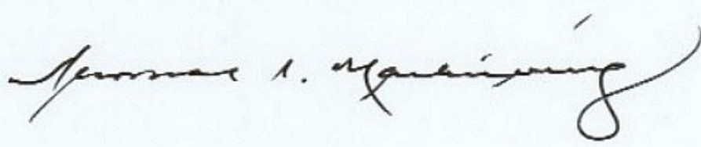

THOMAS S. MARKIEWICZ
Chair

